**Big Mountain Resort Report**

The problem statement that I am looking into is as follows: How can Big Mountain Resort increase revenue this season to cover the $1,540,000 operating costs of an additional chair lift?

For data wrangling, I loaded the data and looked at the shape and types of data I was working with. Then looked for and eliminated any errors or outliers. Then I eliminated any columns that had too few entries to analyze and any entries that did not have price data because that is what we are trying to analyze. After cleaning the data a bit, I ended up with a dataframe with 277 entries and 25 columns.

In exploring data analysis, I scaled the data. Then used a PCA transformation and plotted the cumulative variance ratio to see how much it is affected by the PCA components. Then I used some visualizations to see if there was a trend in pricing. This showed some semblance of a trend in states that were not Montana. I then used a heatmap to look into the relationships among different features. This helped us to look into runs and total_chairs as a possibility of features that were correlated strongly with price.

In order to find a model that works for this data, first I loaded the Ski resort data and separated out the Big Mountain data so that when it comes time to use it later, that data isn't already part of our model. Then I split the rest of the data into a training set and a test set. I then started with a linear regression model and fed the test set through it. Then I checked the mean squared error and mean absolute error to evaluate the model. Then I used cross-validation to assess the model. I adjusted the linear regression model based on the cross-validation to reduce the error in the results. Then I used a Random Forest Regressor model. After testing it, I again checked the error. After testing the models and looking at the error, I decided to use the Random Forest Regressor model. I also used a bar plot to look at the features that affected the price the most based on this model. As shown below, FastQuads, Runs, Snow Making_ac and vertical drop were the features of importance.

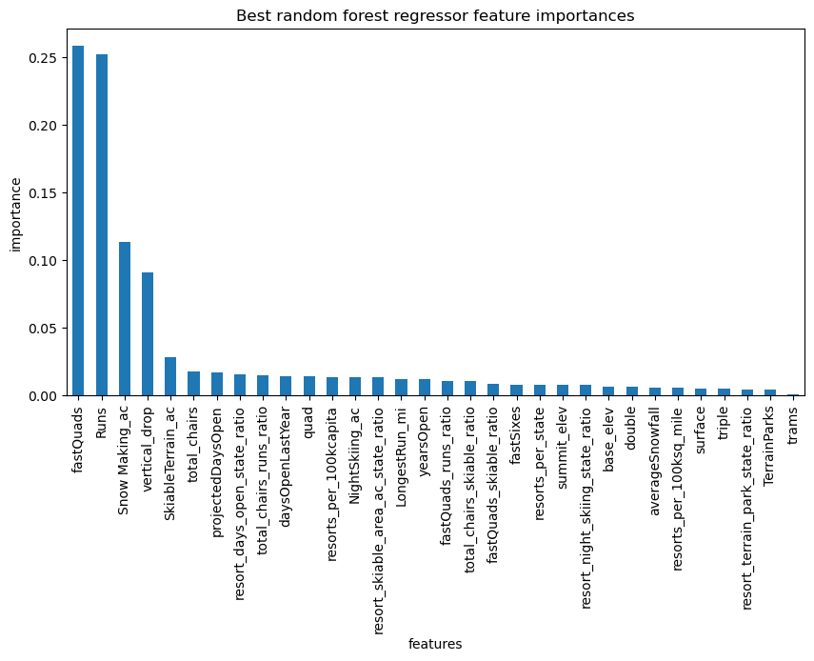

After running Big Mountain’s data through the Random Forest Regressor model, I found that the weekend adult pass should be increased from $81.00 to $95.87. This is based on the pricing data and features of other resorts throughout the country. This price increase will increase revenue in order to cover the operational costs of an additional chair lift.

I also tested a couple scenarios for the future. Closing a run in order to decrease operational costs without changing the ticket price can be done, however, closing more runs would decrease the ticket price, as seen in the figure below.

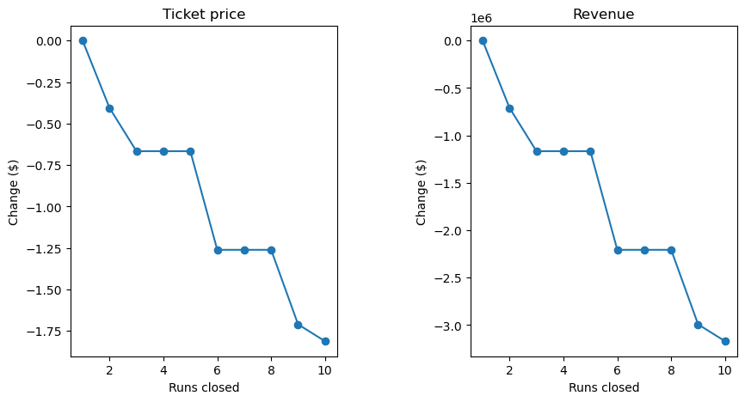

By adding a run and increasing the vertical drop of the resort by 150 feet, the ticket price can be increased by an additional $1.99. However any plans of increasing snow making would not be worth any increase in ticket price according to the model.